WG ICT - softwareleveranciers
Report |  |  | 05-04-2018
convenor | Bart Cieters (AAD&A) & Albert Palsterman (CRNSP)
reporter | Bart Cieters (AAD&A)
present

Info : The topics from CRSNP are in black normal format.
The replies from customs are in blue italic format
The questions from CRSNP are in yellow, normal format.

- EORI for Import

Where a company has an EORI number but no VAT number the PLDA system requires always a code Y040 (VAT number) also for scenario’s where there is no VAT number.
This should be changed.

Our Legal Department has confirmed me that this can be changed in PLDA.Ticket 29654 has been created. This ticket will be part of PLDA17.9.

This issue must be tested (request from Martin)

The ticket has shifted to PLDA17.10.

Awaiting installation PLDA 17.10

- Adapt customs systems to UCC
Organization of ICT-workgroup for data analyses
UCC Compare Cuscar data definition with UCC annex B G3 and G4 definition

The comparison was made on 5/5/2017.
The comparison was made and distributed by email to Customs and all members on 7/5/2017.
The members found considerable differences in concept and data definition between both messages. For further information please refer to the email.
The members would like to be informed on the next steps/planning taken by Customs.
If a BPM session would be advisable some members would like to participate.

Next week there is meeting with the national forum to discuss how we will proceed.

Update: First meeting European ProjectGroup on 11 and 12 September. 13 Member States .Goal is a BPM and Common Specifications for the members of this Project Group

Next meeting : 23 and 24 October 2017. If needed in the upcoming meetings members of the group WG ICT – Softwareleveranciers will be consulted.

During the meeting the BPM for AIR has been discussed. At the end of the meeting it was clear that an agreement wasn’t possible yet. All the participants have taken the possible scenarios back home for further study. Our goal is to have an agreement during the next meeting (12 and 13 December 2017)

The working group is working further on L4 BPM Air. We expect to finalize level 4 at the end of next meeting. Next meeting on 27 and 28 February 2018.

Please report state of play

- Gefeg

UCC GEFEG: has Belgian Customs decided to use the GEFEG tool for UCC data modelling and the creation of the message specifications?
Please advice status.

Tender for tool was published. Tender was necessary because Inspecteur van Financien didn’t agree because there was a problem with the rules of monopoly. Meanwhile we have only received on offer from the company Gefeg. In the upcoming weeks the offer will transferred to Inspecteur van Financien and the tool will be installed.

Please advice status.

The company GEFEG has received on Monday 13 NOV 2017 the purchase order. We hope that the tool can be installed in the upcoming weeks.

Is the purchase final and has the tool been installed in the meantime ?

The purchase has been finalized and the installation of the software is ongoing.

Please report state of play

- Starteam number 23222

Customs will, together with IBM and ICT, investigate whether following statuses can be transmitted.
- Financiële afhandeling opgestart ( contante betaling)
- Klaar voor controle
- Controle door MODA

Because the upgrades to CCFF and CCRM have taken place in the meantime, this issue remains on the agenda.

As mentioned during the last meeting, this will be integrated during the review of the import process

The Item remains on the agenda

Here are the statutes we asked for

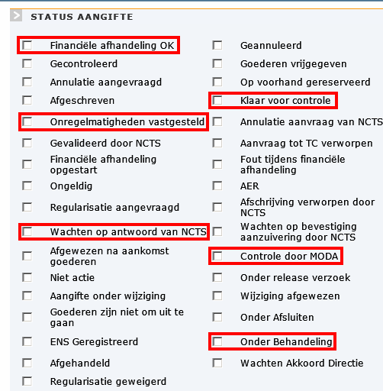

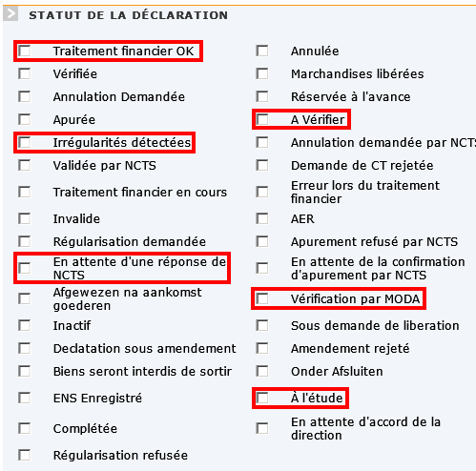

- Integration Export process

For air freight Kristian VDW wants this topic to be treated with priority. Everything would be in place to definitely start this process.
The pilot companies have received the information and the involved members of CRSNP follow this up.

As we understood BAFI distributed a message whereas the electronic process would be mandatory as from 1/9.
On the other hand also a communication around “Brucloud” was introduced.
Moreover Customs distributed a circular on 10/5. The circular is in annex to the report.

Members request the exact planning for the mandatory operational start of this export system and the status of cooperation with Brucloud.

Goods flow export is already available in production. The use of IE507 will be mandatory for the airport of Zaventem.as from 1/9/2017.

Integration export process air cargo: no major issues in sending the charge reports for air cargo.
The members ask for a timing of the next processes: transfer message and export manifest.

29426, 29427 and 29428 have to be solved before export manifest can be used.
Transfer message can be tested.

No further technical issues.
One member (Ziegler) still has no reply from customs. His exports are not confirmed although he follows the (manual)procedure Can there be done something about it ?

Bart Cieters will inform Dorothy Cardoen that the problem hasn’t been solved yet, but Ziegler will also contact the local customs officers to verify why certain excel-lists haven’t been uploaded into the system.

Martin Goblet Ziegler has the following information :
Martin has discussed this problem with Bart Vleugels. Bart Vleugels is aware that there are huge delays in confirming the exit of the goods. There is lack of staff in Zaventem and they can’t confirm the declarations in. So this problem will remain until the complete exportprocess has been activated in Production.
On 10/01/2018 Ziegler has received the confirmation of the exit of the goods of declaraions where the arrival of the goods has been confirmed on 29/11/2017.
Please advice planning.

4 June 2018. The message for the confirmation of the arrival of the goods will be mandatory. Meanwhile we are investigating the start up a pilot for testing the export manifest.

From statistics from Ziegler we understand that there is an organizational issue with the charge messages in Zaventem. Ziegler will show them in the next meeting. We would like to know the background.
There is still also a commercial issue with the use of Brucloud. We understand that the cost can be very high Please find hereafter cost calculation of Ziegler.

Brucloud prices :

Categorie 1: Gemiddeld >1000 AWB’s per maand : 300 € / maand *
Categorie 2: Gemiddeld tussen 500 – 1000 AWB’s per maand : 200 € / maand *
Categorie 3: Gemiddeld < 500 AWB’s per maand : 100 € / maand *

We've 6 companies in Cat 3 and one in Cat 2 : 800€/month

Between 01/09/2017 and 20/03/2018, we've made 5646 export declarations on office BE212000. We would have paid 7 * 800€ = 5600€ : +/- 1€ per declaration !!!

- Limit of 999 tariff items in declaration

In XML it is only possible to send a few hundred items per declaration (200 to 300) without time-out. Iin EDFACT it is however possible to send 999 items without time-out. According to CRSNP, it is not working in XML due to:
- The XML message is much larger than the EDIFACT message?
- The XML message is converted to an EDIFACT message before processing by Customs?

Limit of 999 tariff lines: this has improved, but 999 lines is still problematic.
Important topic for the WG ICT.

Extra monitoring has been added by our ICT Department. More info has been transferred to IBM.

Monitoring has shown us that there is a performance problem with the AEO web service. This problem will be solved in AEO. A new version of AEO will be delivered and we expect to install this version in production in January 2018. After this installation, the monitoring of our applications will go on.

Please advise status

The AEO web service has been updated and no performance issues have been reported on this part of the application. Further monitoring is going on and on Monday new data for investigation has been provided.

The issue remains on the agenda, please advise state of play

- Electronic Consolidation (Globalisatie)

For the moment the project has been set on hold because there is a huge difference in the received statistics from the software houses and from the Customs offices. Further investigation is needed.
Statistics are clear, but the Project is still onhold. Some questions have to be answered but the projectmanager of PLDA didn’t find the time yet.

On 21/11 a meeting of the WG globalisatie has been planned. We understand that the project is on hold because of budget limitations an a great impact on the customs hardware. (Much more data must be processed that today and the actual set-up is not capable to cope with it. Consequently the question is : Makes this meeting still sense ? Or is it cancelled ?

Since Monday 13 November 2017 the project has been resumed. Meeting of 21/11 has been postponed until 19/12.

The meetings have been resumed. First meeting was on 9/1/2018. The application is planned to go live on 1/5/2019. First and next step in the process is the issuing of the specifications. As far as we understood the original idea of working remains.

Indeed the original idea remains

When will the specifications be available ?
We understand the GEFEG tool was used for the data model ?
What would be the added value for the CRSNP members when also using the GEFEG tool. In other words, what is available from BE customs that can be imported or transmitted to the GEFEG tools of the members ?

- Short term planning

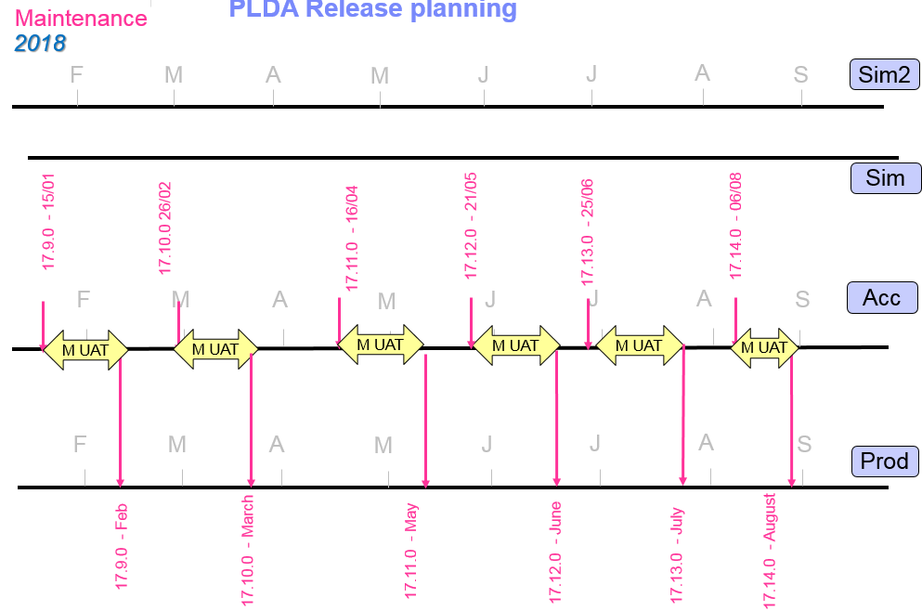

- Expired certificates

How can we, using a Get Status message, after the renewal of an expired certificate request the status of a particular declaration?
It may concern thousands of messages. Many declarations with an Exit Confirmation or “Regularisaties” are not confirmed through the normal IT channels and are retrieved using a Get Status message. How can this be solved ?

David Vandendriessche will attend the next meeting

We are looking forward to his solution proposal.

To solve this problem IBM needs to update the structure of the database. By mid 2018 it should be possible to solve this issue in prod.

This issue is treated in the sub committee “communicatie en authenticatie”
See topic further in this report.

- NCTS :

- NCTS Roll out (pdf)

It is still not clear what offices will be using the new NCTS application and when they will activated.
Can this be clarified ?

New offices will be rolled out shortly/finally i.e. BE408000 and BE432000. We hope still before the end of June. Others will follow once we notice no major issues (or the issues solved).
The idea is to have them changed by clusters of ESD/TAO. Starting up with “Gent”-offices.
The goal is to have by the end of 2017 all offices should be in NCTS-RW.

Is there a planning for the next offices after the ones that have been announced?

BE408000 and BE432000 have been switched to NCTS-RW.

The roll-out for next offices depends about how big and troublesome the lessons learned are from this roll-out.
Except the fact that the next offices to be rolled out will be in Flanders, we did not come up with a newly fixed planning yet.
Please note however we already came to the conclusion no more than 2 offices will be migrated at a time.
In any case we do stress upon the fact
Traders must be aware they should have their email-address for receiving the TAD linked to their EORI (eori.be@minfin.fed.be)
Traders working in Simplified procedure, should ask regional KLAMA-services to check if their authorizations are correctly and fully registered in the DB of Authorizations. Once their authorizations is registered in this DB, they can ask ncts.helpdesk@minfin.fed.be to register their UNLO-Code also in the actual NCTS so they can start using the UNLO-code instead of the VP-code
The use of “camion…truck” as identity of means of transport, is yet not allowed, and in the new system checked by the system. So this is not something new…
Before we roll out a new office we do the exercise in TEST with PROD-data. For traders it means that if they ask for it, they can already test if their application is congruent to what is coming up.

In the attached file you’ll find the planning of the migration. This planning can still change.

We are looking forward to the upgrades. However we would have preferred that only the involved offices would be out of service and not the whole Belgian NCTS application.
Is the plan still to upgrade all offices before 1/7/2018 ?

- Emergency procedure NCTS

There are a few issues which we want to bring to the table for general clarity :
- It is not possible to print a red stamp on the document. Can this not be replaced by a text or stamp in normal color ? Printing in color is not common. The issue was already reported a few times.
- There are no local offices anymore. It results in the fact that truck drivers sometimes have to drive large distances to the next nearest customs office. It makes the emergency procedure very impractical for many users. Is there no work around possible for general use ?

- Cuscar

About the new field for the representation (direct/indirect): Which EORI must be submitted, always the one from the declarant ? Is this the EORI of the Ship owner/operator when direct representation and the EORI of the agent when indirect representation ?

Reply not yet received from the claims department.

Please advise state of playl.

Cuscar Transfer (overbengen)

Can customs supply us a example message with function code 8 ?
Has customs already tested the message ?
Is there no UNB segment missing ? During development our specialist was of opinion that the message cannot work without it since missing essential data
As we understood from the last meeting WG binnenbrengen of 29/9 there is no customs instruction / procedure yet how to use the “Transfer” function of specifying the responsibilities and way of use.
When is it expected to be ready ?

As discussed during the CRSNP meeting of 14/11/2017, Cuscar RTO will be used by customs and softwareproviders as a test case to publish technical as well as functional specifications for this change. Customs will publish asap the necessary info.

After the last exchange and supply of data from customs several softwareproviders have been able to send a technical perfect message and received answers from Customs. The thing that is still missing is a part of the use case.
More on how the message should be used in practice.
Software providers do not understand how this message works in practice.
I.e. Who will be sending the message ? The departing or receiving TS operator ?
How will he identify himself ? Will he need to have an agent code or an Eori number or both ?

Is there already a reply or instruction how this should be used in practice ?

- Locations codes box 30

One of the files from Customs was corrupt, but this was already replaced with a correct file.
The new location codes we’ve received on 1/11 directly from customs, removed
The code list is not complete, for example following codes are missing (including the MRN of the declaration that had these codes)

BEBRUZ1124001 17BEA0000038367389
BEDTOZ3161002 17BEI0000038403207
BEANR00524 17BEE0000038796308

This issue will be checked by martin and reported later if still existing

BEANR00524 was present in the file of 1/11

BEBRUZ1124001 wasn’t present in the file because this location code has an end date of 10/05/2016

BEDTOZ3161002 wasn’t present in the file. Ticket 29690 has been created for further investigation.

After investigation by Martin :
BEANR00524 was present in the file of 1/11 : OK in recente extracten
Solved
BEBRUZ1124001 wasn’t present in the file because this location code has an end date of 10/05/2016 : nog altijd in gebruik en gevalideerd in AC4 : MRN 18BEA0000001610220 van 11/01/2018.
BEBRUZ1124001 was present in the message of declaration 18BEA0000001610220 . This looks also ok to me.
BEDTOZ3161002 wasn’t present in the file. Ticket 29690 has been created for further investigation. => OK in laatste extract
Solved

The above issues where solved but we do not receive any good files anymore. The files are corrupt. Please try to send us a new updated uncorrupted file.

- Meeting Raad van bestuur CRSNP/WG ICT met Chris De Clercq & Bart Cieters

This meeting has taken place as foreseen and a report has been distributed to the members.
Some topics need further follow-up.

Cuscar Transfer (overbrengen) was indicated as a sample / pilot project in order to be sure that everything was available in order for the softwareproviders to develop efficiently and correctly new messages

After some additional request the organization received a specification and a sample message.
Which allowed the software providers to develop a technical working message.
The only thing what is still is the use case. (see topic above)

CRSNP members also asked for the business annalists for the applications.
CRSNP already supplied the list. But we would like to have some names associated with the applications. Can the fact that no use case was provided for the Cuscar transfer project be related to the fact that no business annalist was provided for the project ?

PLDA invoer en uitvoer : Bart Cieters / Wouter De Vlieger
NCTS : Alejandro Maria Aragon / Frank De Maeyer
Goederencomptabiliteit (GC) : NO customs BA / only BA IBM
ICS (ENS) : Wim Baetens
ECS (EXS) : Wouter De Vlieger
EMCS : Jurgen Vanhoyland / Carine Frère
AC4 : Bart Cieters / Jean-Baptiste Halleux
EIR : Bart Cieters

The Item can be removed

- Meeting on communication and authentication

IT customs wants to move NCTS and PLDA to the same communication protocol
Following protocols are offered: Web services/FTP/AS2/IDcard or token.
A separate meeting will be organized by the CRSNP communication providers for the members that perform communication. Descartes will take the initiative and inform the result to customs.

A meeting with a smaller group of softwareproviders has been scheduled. First meeting will take place on 23 November 2017.

The members have expressed their concern in a message to the customs authorities regarding the new way of communication. The topic has a general impact on all economic operators and should be treated on a national forum level. A preliminary meeting with a small delegation of communication providers is foreseen on 6/2 10.00 h in NG probably room A13

Meeting is foreseen on 8/2/2017. Meeting Room A08

The report on the meeting “communicatie en authenticatie” held on 8/2 sheds more light on the resolution of this issue.
We are looking forward to the next meeting on 19/4.

- Change “Charge report” to use as “Arrival at Exit” (IE507) for the terminals.

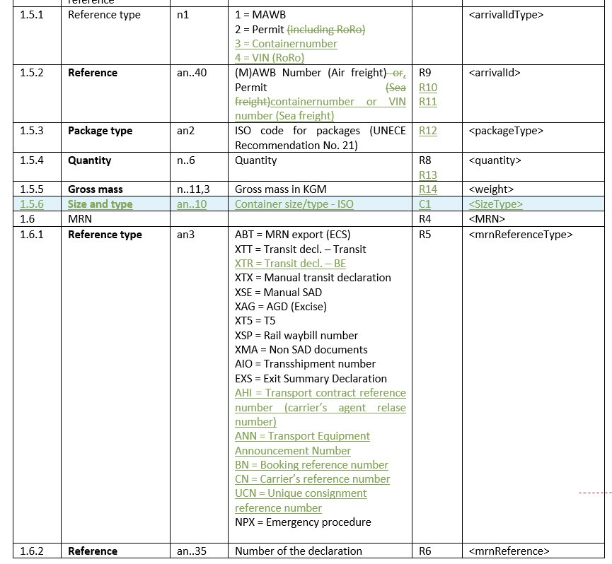

Foreseen in PLDA17.10, but not yet confirmed.

When will this message be available for testing ?

- New measures Tarbel (1/2/2018)

For measures 748/749, the impacted commodity codes :

Description | CN Code
Mercury (I) chloride (Hg2Cl2, CAS RN 10112-91-1) | ex 2852 10 00
Mercury (II) oxide (HgO, CAS RN 21908-53-2) | ex 2852 10 00
Cinnabar ore | ex 2617 90 00
Mercury sulfide (HgS, CAS RN 1344-48-5) | ex 2617 90 00;  ex 2852 10 00
Mercury (II) sulphate (HgSO4, CAS RN 7783-35-9) | ex 2852 10 00
Mercury (II) nitrate (Hg(NO3)2, CAS RN 10045-94-0) | ex 2852 10 00
Mixtures of mercury with other substances, including alloys of mercury, with a mercury concentration of at least 95 % by weight. | ex 2620 60 00;  ex 2843 90 10;  ex 2853 90 00;  ex 2853 90 90

Also measure 420 is a new measure. A list of commodity codes will be communicated as soon as available
As far as we understand this information was not totally correct : new measures were 420, 728 and 748. 749 existed already in 2011.

- Regularisatie aangiften (nieuw)

Volgende bemerkingen werden ons ter beschikking gesteld via douane :

“Zoals gezegd mogen wij geen regularisaties meer toestaan zowel bij bestemming als bij vertrek nadat wij een vaststelling gedaan hebben. De aangiftes blijven in de status “onregelmatigheden vastgesteld”
Bij vertrek dienen jullie een nieuwe aangifte op te maken.
Dit volgens artikel 173 paragraaf 2 van het DWU;

“Artikel 173
Wijziging van een douaneaangifte
1. De aangever wordt, op zijn verzoek, toegestaan een of meer gegevens in de douaneaangifte te wijzigen nadat deze door de douane is aanvaard. De wijziging mag niet tot gevolg hebben dat de douaneaangifte betrekking heeft op andere goederen dan die waarop zij oorspronkelijk betrekking had.
2. Dergelijke wijzigingen worden niet toegestaan als het verzoek daartoe wordt gedaan na een van de volgende gebeurtenissen:
a) de douaneautoriteiten hebben de aangever in kennis gesteld van hun voornemen de goederen aan een onderzoek te onderwerpen;

b) de douaneautoriteiten hebben geconstateerd dat de gegevens van de douaneaangifte onjuist zijn;
c) de douaneautoriteiten hebben de goederen vrijgegeven.”

Lisette Wijnen
Adjunct Fiscaal Deskundige
FOD Financiën / Douane en Accijnzen / Toezicht, Controle en Vaststellingen
TCV Bilzen
Kruisbosstraat 16 3740 Bilzen
Tel: +32 257 584 99 / Gsm: +32 4707 584 99 / Dienst +32 257 52150
Dienst mail: da.tcv.emt.bilzen@minfin.fed.be”

Because of this new way of working, declarations that have been verified and on which anomalies have been established are left in the BTB applications in a status MRN and cannot be processed any further. In the PLDA web they are left in status “onregelmatigheden vastgesteld” Customs does not send any further messages.
In practice this means that no proof or document is received from customs by the importer or exporter in order to prove the regularly imported or exported goods.
On the other hand we understand that some customs offices demand a new electronic declaration without reference to the previous one, leaving the system with two declarations for the same shipment.
The issue is also escalated to the WG “Algemene Bepalingen”, but it is necessary that PLDA provides a uniform and automated solution (as in NL,DE..)

An exhaustive e-mail has been sent to WG Algemene Bepalingen in order to supply a solution.

- Declaration type D

The declaration type D is sent to customs before presentation of the consignment to customs in order to write off the GC.

However we have noticed that still declarations go wrong. They receive an MRN when submitted to customs, but later, after arrival of the ship, they receive again an error

Questions :
What checks are performed after the arrival of the vessel that cause these errors ?
What error messages can be expected ?

- Issues test system

Would it be possible to copy again the EORI database to the test systems.
Ziegler has 15000 correct declarations which are readily available to be sent to the test system for testing new applications but 1879 of declarations get now errors because the EORI numbers are not in the test database.
This is also the case for the BTW verleggingen ET14000…

- Issues with the Taric system

The Excise tariffs for tobacco are missing from the Excel file
Can this be corrected?

- General delay since some time

The general performance of PLDA on some points seems to be deteriorating
A .pdf outprint of a released document is received nearly immediately, whereas the XML message of the release (on which the printed document is based) is sent one hour later

Performance of NCTS is even worse.

Question : Can customs monitor the performance of their systems ?

If needed we can give some statistics.

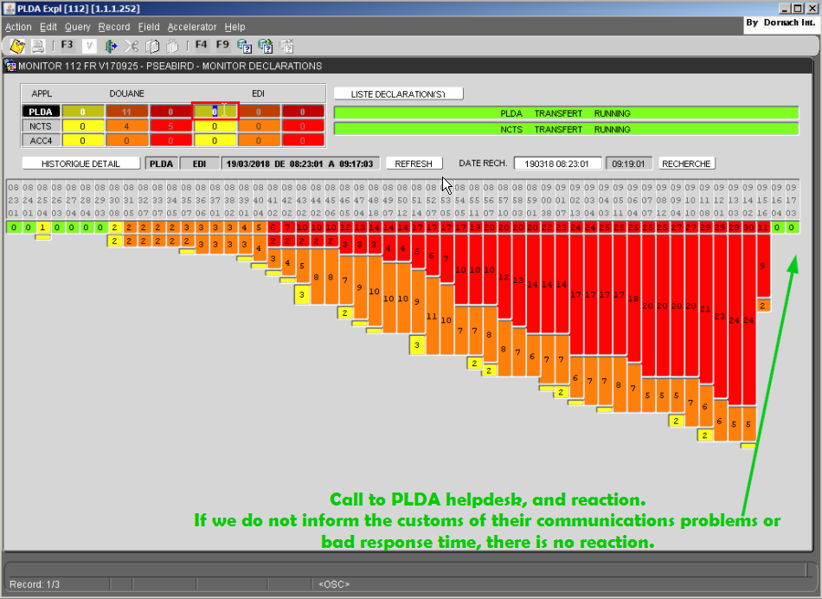

Einde verslag

